# Machine Learning Lab 2

Junming Zhang 29299527 [jz1g17@ecs.soton.ac.uk](mailto:jz1g17@ecs.soton.ac.uk)

Problem 1 and 2

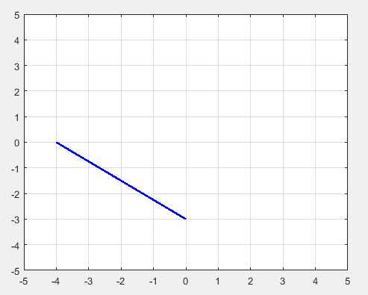 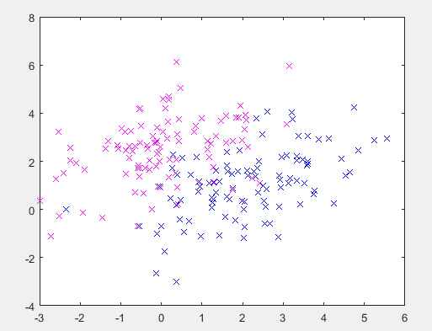

*Figure 1.1: line: $3x+4y+12=0$*  *Figure 1.2: Gaussian distribution with different mean*

$a1x+b1y+c1=0$ is a line equation, kron command will return the Kronecker in this case, $a1=3, b1=4 and c1=12$ product of two matrix. thus, it could be used to two points: $(\frac{-c}{b1}=-3,0), (\frac{-c}{a1}=-4,0)$ shifting the mean of one distribution. are used to plot the line.

Problem 3

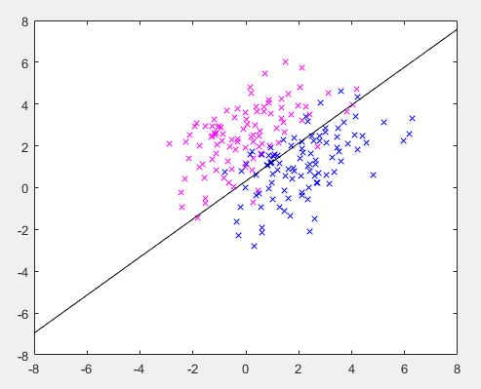

*Figure 1.3:Bayes’s optimal class boundary*

Suppse the densities are isotropic and prios are qual which are $\vec{C}=σ^{2}*\vec{I} and P\left[w1\right]=[w2]$

$$\frac{1}{{\left(2π\right)}^{\frac{p}{2}}{(\det\left(C\right))}^{\frac{1}{2}}}exp\left\{-\frac{1}{2}{\left(\vec{x}-{\vec{m}}_{1}\right)}^{t}{\vec{C}}^{-1}\left(\vec{x}-{\vec{m}}_{1}\right)\right\}P\left[w1\right]<|>$$

$$\frac{1}{{(2π)}^{p/2}{(det⁡(C)}^{1/2}}exp\left\{-\frac{1}{2}{(\vec{x}-{\vec{m}}_{2})}^{t}{\vec{C}}^{-1}(\vec{x}-{\vec{m}}_{2})\right\}P\left[w2\right]$$

Cancel common terms and take log

$${\left(\vec{x}-{\vec{m}}_{1}\right)}^{t}{\vec{C}}^{-1}\left(\vec{x}-{\vec{m}}_{1}\right)<|>{\left(\vec{x}-{\vec{m}}_{2}\right)}^{t}{\vec{C}}^{-1}\left(\vec{x}-{\vec{m}}_{2}\right)-log\left\{\frac{P\left[w1\right]}{P\left[w2\right]}\right\}$$

To rewrite $\vec{w}=2{\vec{C}}^{-1}\left({\vec{m}}_{2}-{\vec{m}}_{1}\right)=\left[\begin{matrix}3.3333 \\ -3.6667\end{matrix}\right]$

And $b=\left({\vec{m}}_{1}^{t}{\vec{C}}^{-1}{\vec{m}}_{1}-{\vec{m}}_{2}^{t}{\vec{C}}^{-1}{\vec{m}}_{2}\right)-log\left\{\frac{P\left[w1\right]}{P\left[w2\right]}\right\}=1.6667$

The boundary is ${\vec{w}}^{t}*\vec{x}+b$ $w_{1}x_{1}+w_{2}x_{2}+b$ $x_{2}=-\frac{w_{1}}{w2}x_{1}-\frac{b}{w_{2}}$

Therefore the line equation is $y=-\frac{3.3333}{3.6667}x_{1}+\frac{1.6667}{3.6667}$ which is shown as Figure 1.3.

Problem 4

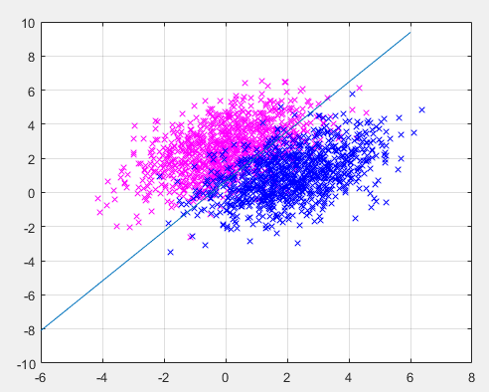

*Figure 1.4:Bayes’s optimal class boundary*

To finish the code in the Appendix, the first step is set up the existed data with label 1 and -1

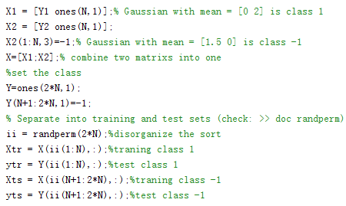

The second step is set the weight and learning judgement equation to adjust the weight with a correction equation.

The last step is use the learned weight to draw the boundray line for classfication which is shown in Figure 1.4 and observe the Error percentage.

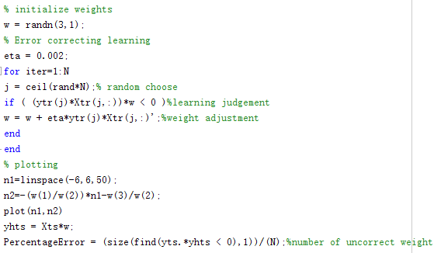

This part is not finish cause the learning process is unstable due to only trian same input data once, therefore the output weight may wrong in this case. To obtain a high accuracy weight need more train process with same data.